|  |
| --- |
| Microsoft SharePoint 2013 - Hands-on Lab |
| Working with Access Services |
| Verified Against Build 15.0.4420.1017 |

|  |
| --- |
| Microsoft  Version 1.0  25th of June, 2012 |

Information in this document, including URL and other Internet Web site references, is subject to change without notice. Unless otherwise noted, the example companies, organizations, products, domain names, e-mail addresses, logos, people, places, and events depicted herein are fictitious, and no association with any real company, organization, product, domain name, e-mail address, logo, person, place, or event is intended or should be inferred. Complying with all applicable copyright laws is the responsibility of the user. Without limiting the rights under copyright, no part of this document may be reproduced, stored in or introduced into a retrieval system, or transmitted in any form or by any means (electronic, mechanical, photocopying, recording, or otherwise), or for any purpose, without the express written permission of Microsoft Corporation.

The names of manufacturers, products, or URLs are provided for informational purposes only and Microsoft makes no representations and warranties, either expressed, implied, or statutory, regarding these manufacturers or the use of the products with any Microsoft technologies. The inclusion of a manufacturer or product does not imply endorsement of Microsoft of the manufacturer or product. Links are provided to third party sites. Such sites are not under the control of Microsoft and Microsoft is not responsible for the contents of any linked site or any link contained in a linked site, or any changes or updates to such sites. Microsoft is not responsible for webcasting or any other form of transmission received from any linked site. Microsoft is providing these links to you only as a convenience, and the inclusion of any link does not imply endorsement of Microsoft of the site or the products contained therein.

Microsoft may have patents, patent applications, trademarks, copyrights, or other intellectual property rights covering subject matter in this document. Except as expressly provided in any written license agreement from Microsoft, the furnishing of this document does not give you any license to these patents, trademarks, copyrights, or other intellectual property.

Copyright © 2012 Microsoft Corporation. All rights reserved.

Microsoft and SharePoint are either registered trademarks or trademarks of Microsoft Corporation in the United States and/or other countries.

The names of actual companies and products mentioned herein may be the trademarks of their respective owners.

# Technical Background

This lab requires you first run a script that creates a dedicated SharePoint site collection that you will use throughout all exercises in this lab. By working in an isolated site collection, you can rest assured that your changes will not affect other sites in the environment.

## Create Lab SharePoint Site Collection

In the files provided with the hands on lab, run the batch file called SetupModule.bat by double clicking it. This file will execute a PowerShell script that will create a new site collection at [http://intranet.contoso.com/sites/](http://intranet.contoso.com/sites/IntroSpApps)Access.

|  |
| --- |
| Description: C:\Users\vesaj\Pictures\DVD_ART36\Artwork_Imagery\Icons - Illustrations\_ SUPER VISTA STYLE\yield sign red white exclamation point.png **Important** |
| *It is important you run this batch file to create the site collection before working through any of the exercises as the exercises contain instructions for working with this specific site collection at the specific URL created by the script.* |

The script will first check to see if there is already a site collection at the specified address. If there is it will delete the site collection before creating it. Therefore if you run into problems with the lab, feel free to rerun the batch file to reset the environment and restart the exercise.

# Introduction

## Estimated time to complete this lab

60 minutes

## Objectives

After completing this lab, you will be able to:

* Create a new Access Services database
* Design tables and queries
* Work with the Access 2013 forms designer

## Overview of Lab

In this lab you will create a new Access Services database and create common objects such as tables, queries and forms.

## Virtual Machine Technology

The computers in this lab are virtual machines that are implemented using Microsoft Hyper-V. Before starting each virtual machine, ensure you apply the **Start-Lab** snapshot. When you have started a virtual machine, log on by pressing **CTRL+ALT+END** and supply the credentials listed in the lab instructions.

## Computers in this lab

This lab uses virtual machines as described in the following table. Before you begin the lab, you must start the virtual machines and then log on to the computers.

|  |  |
| --- | --- |
| **Virtual Machine** | **Role** |
| {Supplied by Instructor} | Domain Controller |
| {Supplied by Instructor} | Actual SharePoint environment with Office client and other required software. |

All user accounts in this lab use password {Supplied by Instructor}.

## Lab Setup Script

In the files provided with the hands on lab, run the batch file called **SetupModule.bat** by double clicking it. This file will execute a PowerShell script that will create a new site collection at [http://intranet.contoso.com/sites/Access](http://intranet.contoso.com/sites/Access%20) .

# Exercise 1: Creating an Access Services Database

* 1. In this exercise, you will create a new Access Services database and verify that creating this database has also resulted in the creation of a SharePoint app within the host SharePoint site.

1. Begin this task logged on to **SP** as **CONTOSO\Administrator**
2. Launch Internet Explorer and navigate to the site created by the **SetupModule.bat** script, [http://intranet.contoso.com/sites/Access](http://intranet.contoso.com/sites/Access%20) .

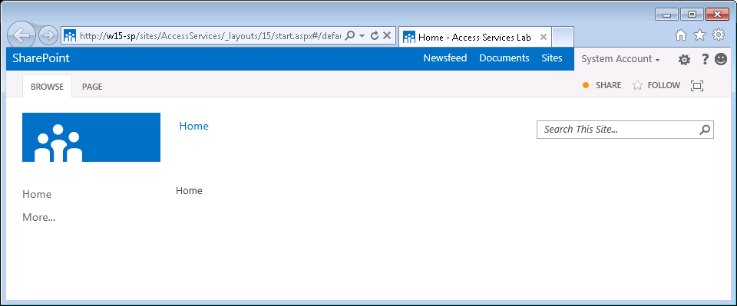

1. Launch Microsoft Access 2013.
2. When Access has started, you should see a welcome screen that shows several different database templates you can use to create a new Access database. Click the first one named **Blank app** to create a new Blank database. Provide an **App Name** of **Access Lab** and a **Web Location** of **http://intranet.contoso.com/sites/Access**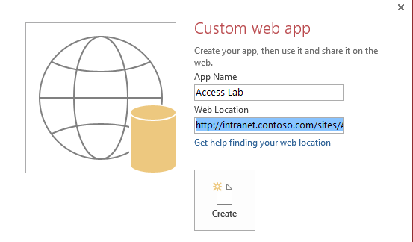 then click the **Create** button.
3. After the database has been created, you should see the following screen in Access.

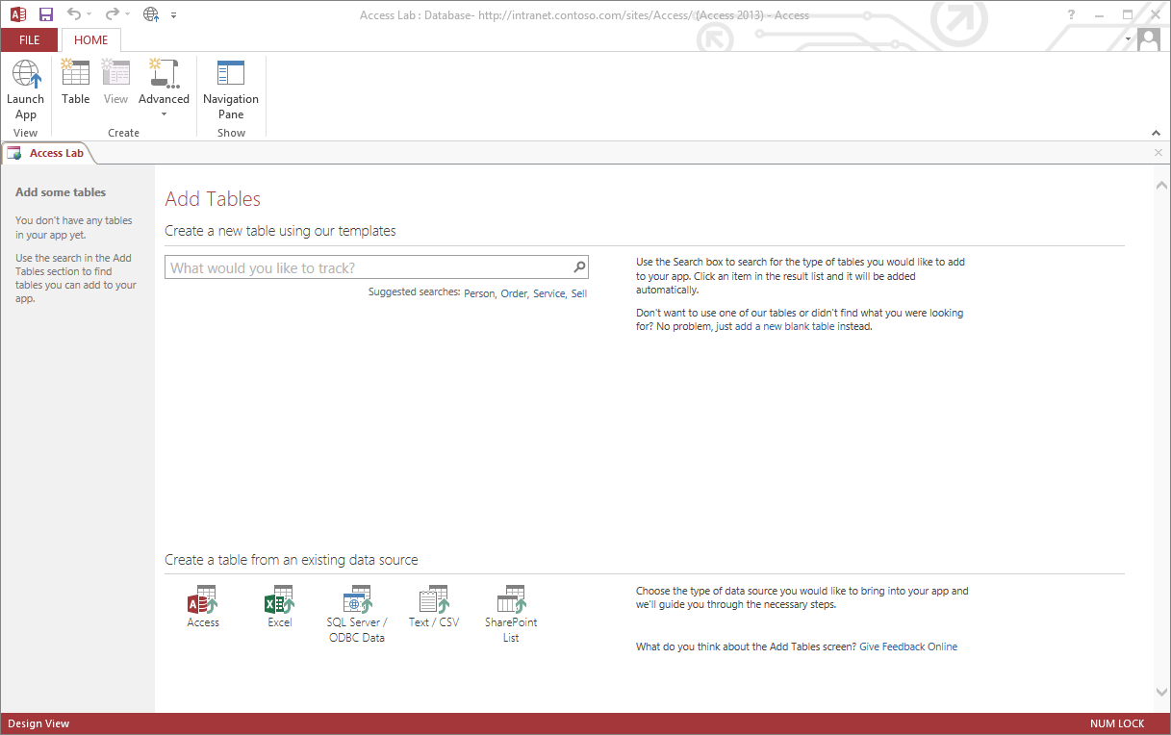

1. You have created a new database but it contains no tables yet. Now you will create a simple table. Begin by clicking **add a new blank table** link on the right hand side of the screen.

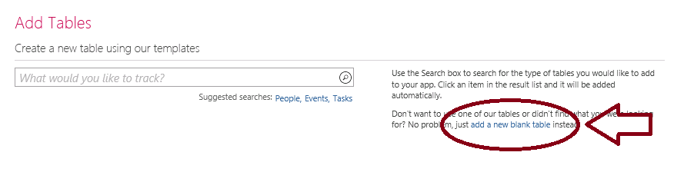

1. At this point, you should see the Access table designer that has a new table with a single column named ID.
2. Create a second column named **Company** based on the Data Type **Short Text**. Click the Save button at the top left of the Access window and save the table with the name **Companies**.

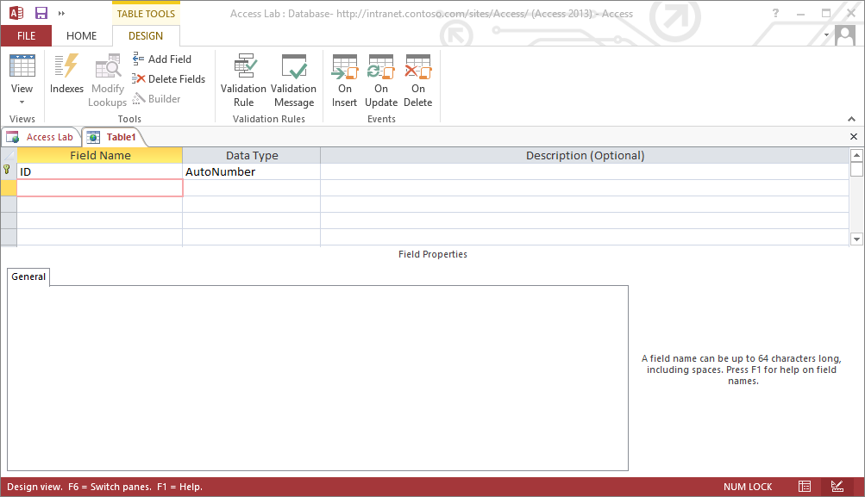

1. Now that you have create an Access Services database with a simple table, it’s time to take a look at the SharePoint app that has been created to provide access to this database. Return to the browser and navigate to the site that was created at **http://intranet.contoso.com/sites/Access** and click on Site Contents to see the apps that have been installed for the site. You should see a tile for the Access Service app with a caption of **Access Lab**.

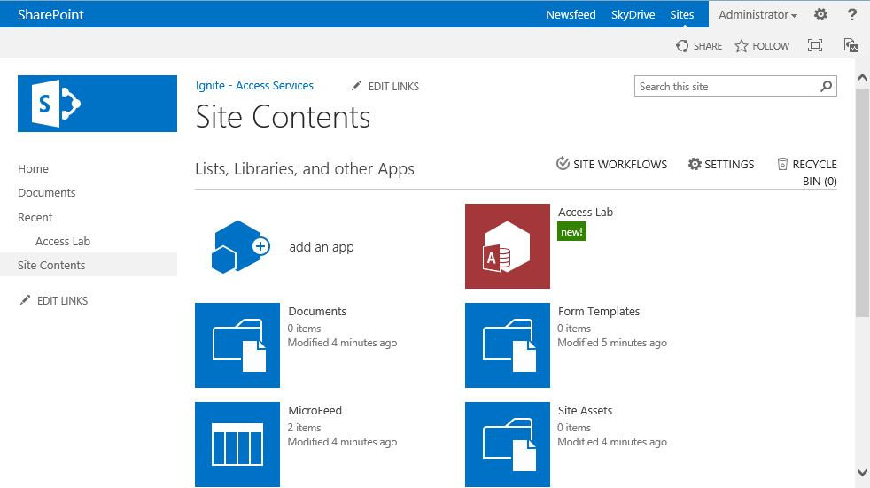

1. Click on the **Access Lab** tile to navigate to the SharePoint app that has been created for the Access database.
2. When you have navigated to the app for the Access database, you should see a link to the page for the **Companies** table. You should also observe that the page for the **Companies** table is displayed by default because that is the only table in the database.

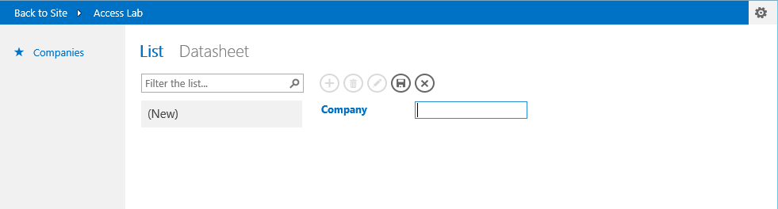

1. Type the text “Wingtip Toys” in the **Company** text box and click **Save**. A new record is saved to the database.
2. Click the button with the plus (+) sign to add second company named “Adventure Works” and click the Save button.

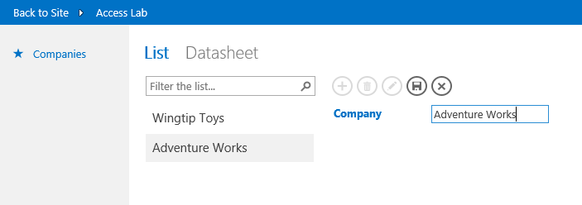

1. After adding the records for the two new companies, click the **Datasheet** link to see how data looks in datasheet view. Note that you can easily add new records by selecting the bottom cell and typing to enter the data for a new record.

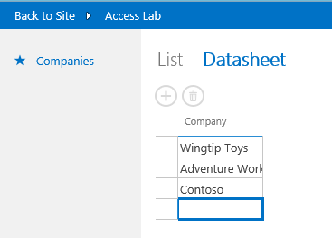

1. Now close the browser and return to Access. If the Companies table is still open in design view close it. At this point you should just see a screen that show what the home page of the SharePoint app will look like. In the top left, you should also see a button with the caption **Launch App**. Click this link to navigate to the automatically navigate to the home page of the SharePoint app.

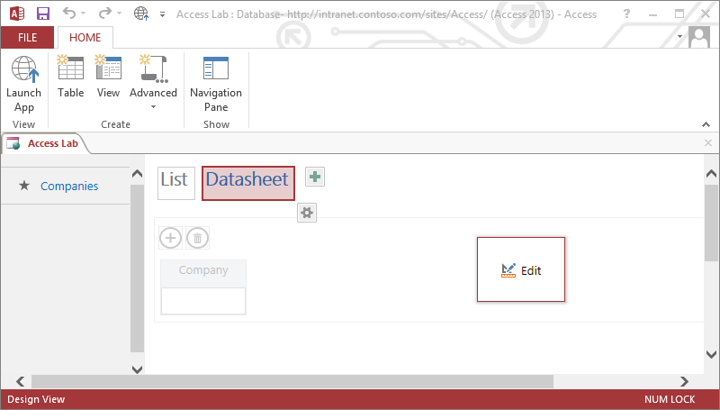

1. When you click the **Launch App** link in Access, you will navigate to the home page of the SharePoint app that you are designing with Microsoft Access. Now you have seen how you typically work when designing an Access Services database. You create and design something in Access such as a table, query, form or macro. Then you click on **Open in Browser** to test you work by examining the user experience through the browser.

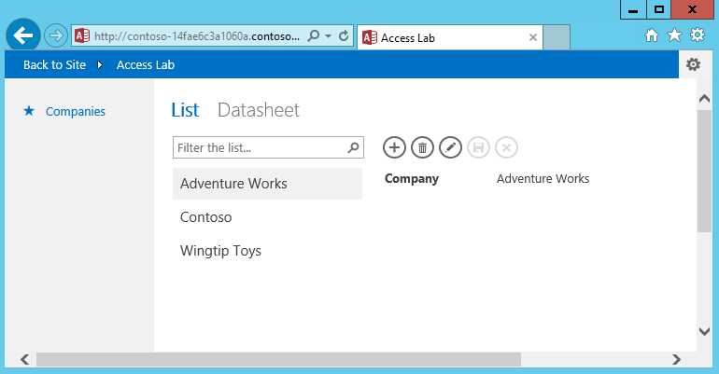

# Exercise 2: Designing Tables and Forms

In this exercise you will continue to work with Access Lab database you created in exercise 1 by importing data for a new table and designing a custom form.

1. At this point you should be back in Microsoft Access and have the **Access Lab** database open from the previous exercise. Click the **Table** button on the ribbon to return to the screen where you create new tables.
2. In this step you will begin the process to import data from an Excel spreadsheet. Begin by clicking the Excel icon at the bottom of the screen to begin the import process.

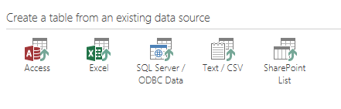

1. When you click the Excel icon, you are prompted to select a source file for the import. Select the Excel file in the **StarterFiles** directory for this lab named **Customers.xlsx**. Click **OK** after you have selected the file.

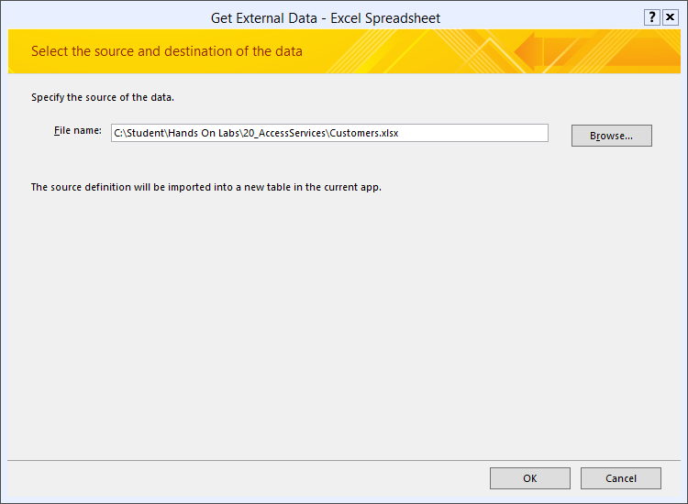

1. On the next dialog, enable the checkbox with the caption **First Row Contains Column Headings**. Then click the **Next** button.

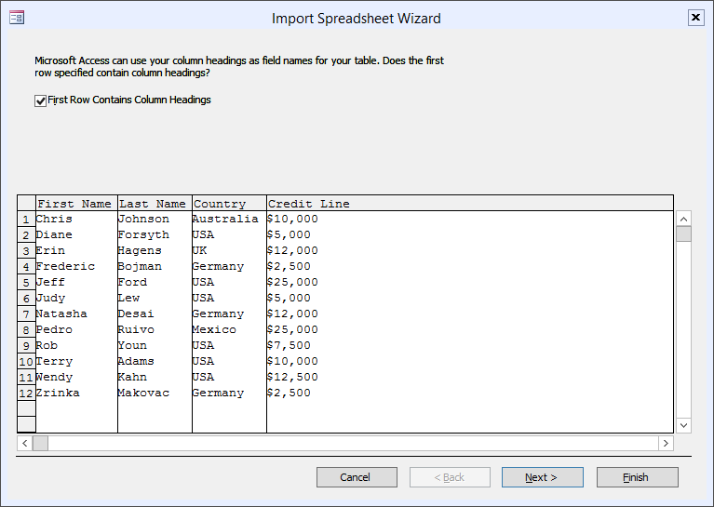

1. At the end of the import process, Access will prompt you to provide a name for the new table. Give the new table a name of **Customers** and click **Finish**.

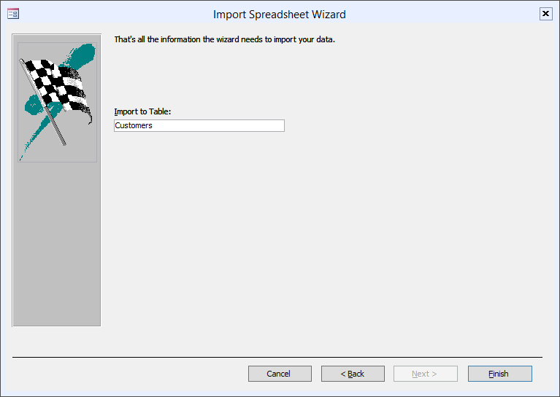

1. You should see a dialog that confirms the import operation completed successfully. Click the **Close** button.

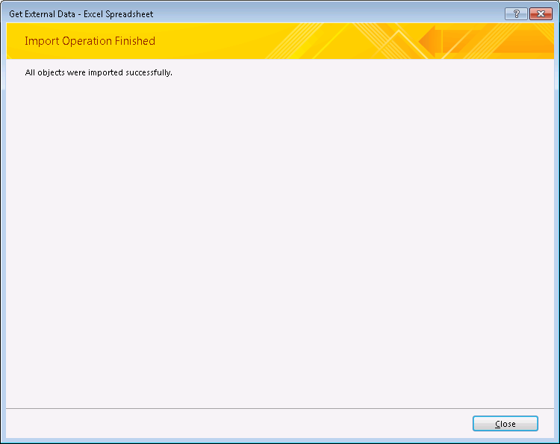

1. After importing the table, Access show the table in design. Now look in the ribbon and locate and click the **Navigation Pane** button so you can see what objects have been created in the Access database.

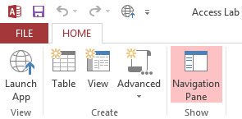

1. Inside the Navigation Pane, you should be able to see that the import process created a new tabled named **Customers** as well as two new forms named **Customers Datasheet** and **Customers List**.

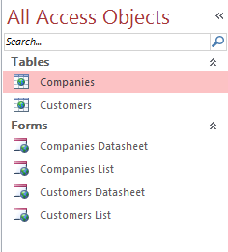

1. Double-click on the **Customers** table to open it in Design View. You should see that the table already contains an ID field and four other fields named First Name, Last name, Country and Credit Line. Add a new field named Notes based on the **Long Text** Data Type. When you are done, save your work.

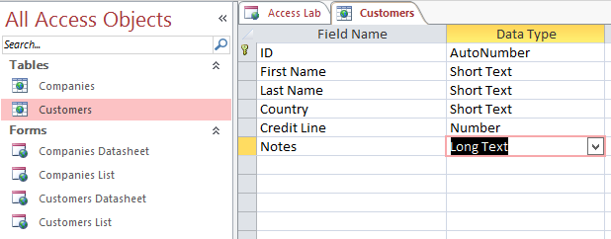

1. Now return to the Navigation Pane and double-click on the form named Customers List to open it in design view. The large rectangle on the left provides the navigation filter. Currently, the navigation filter shows just the first name. Click the button at the top right of the navigation filter with the database icon to change its properties. When you see the property sheet, assign the values as shown below.

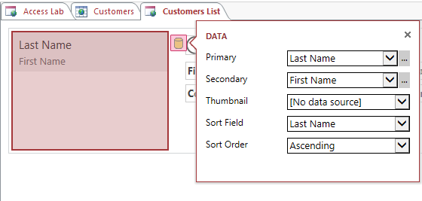

1. When you are done modifying the navigation filter, turn your attention to the controls on the right-hand side of the form.

